DSA THEORY (3B) 2020.

ASSIGNMENT 03

ALGORITHM AND CODE OUTPUTS.

MUHAMMAD DANISH | CS182019 | 3B . **COURSE INSTRUCTOR**: Miss Aneela Nargis

**Condition:** infix expression input.

**Output:** postfix expression output.

**Program Algorithm:**

Load string s;

For:

If: s[i] == operand;

Print s[i];

End if.

Else if: s[i] == opening paranthesis

Stack.push(s[i]);

End else if.

Else if:

End else if.

End for

**Code output Screenshot:**

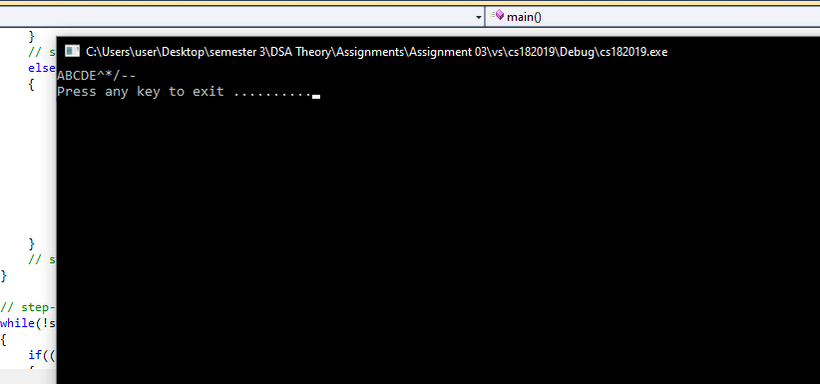

X --------------------------------------------------------------------------------------------------------------------------------------X

MUHAMMAD DANISH | CS182019 | 3B . **COURSE INSTRUCTOR**: Miss Aneela Nargis